**Cloudtopia Passport Office**

On this practice project, we used AWS services to assess users’ passport photos for their complaince to the national passport photo standards.

Design Process

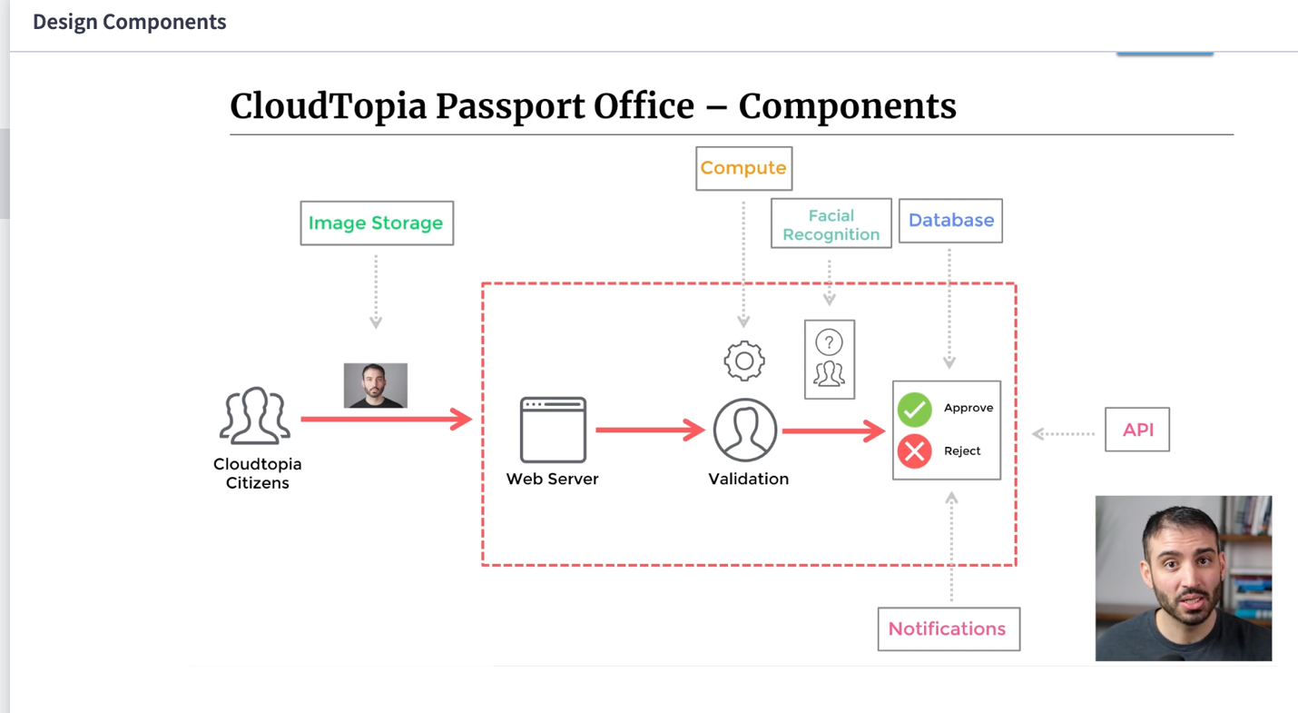

Image Storage

Compute

Facial Recognition

Database

API

Notification

Core Techology Choice

**Image Storage**

EFS:

S3 Raw data storage

Can communicate via APIs

Can do Archive

**Compute**

Needs : Event Processing

API interacting with DB

EC2 – We need to be notified no support on ec2

AWS Fargate

Create Tasks

Services

X We need consistency

AWS Lambda

Serverless

Functions

Cold Start to solve provisioned concurrency

S3 will invoke our Lambda function

**Facial Recognition**

Face detection & Analysis

Amazon Rekogition

Confidence Band

**Database**

Needs Key value record storage

RDS - we don t have a use case here

Aurora – Relational - Serverless v2

DynamoDB – Key value look ups

Horizontally Scalable

Managed

Cost Efficient

**Notifications**

Needs – Message Publishing

SQS

Event bridge – Message Buses

Failed – Passed can be directed

Schema discovery

Integration with outside is possible

Over advanced

SNS (Simple Notification Service)

Simple but powerful

Works good on this project

**API**

GraphQL

AWS API Gateway

Rest API

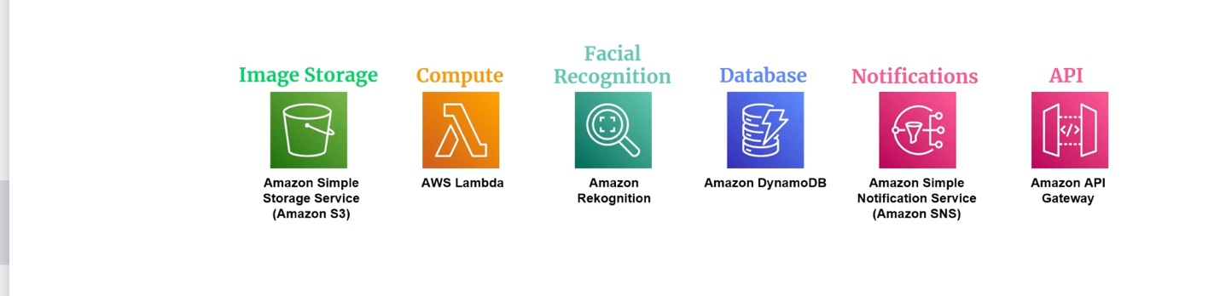

**END DESIGN**

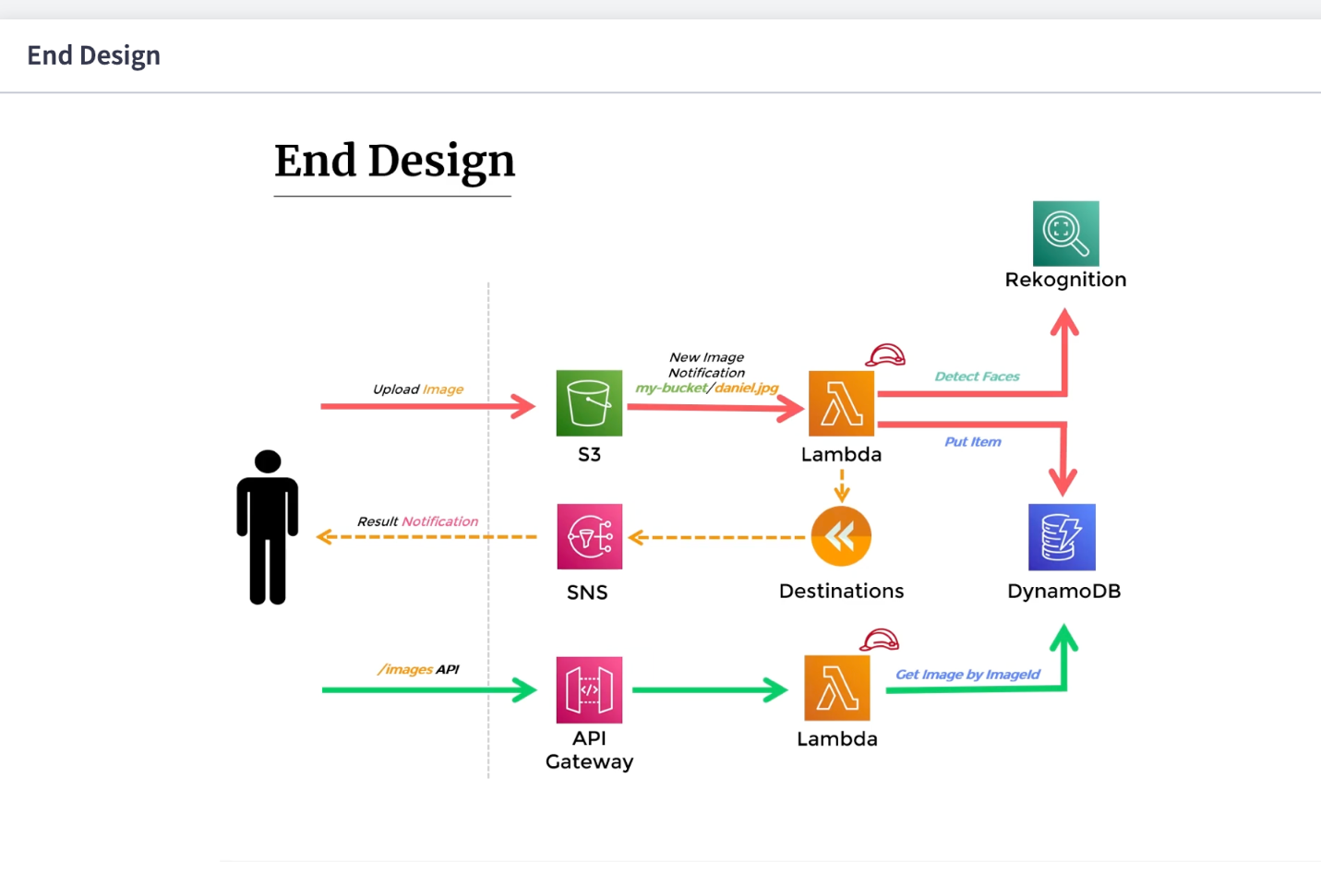

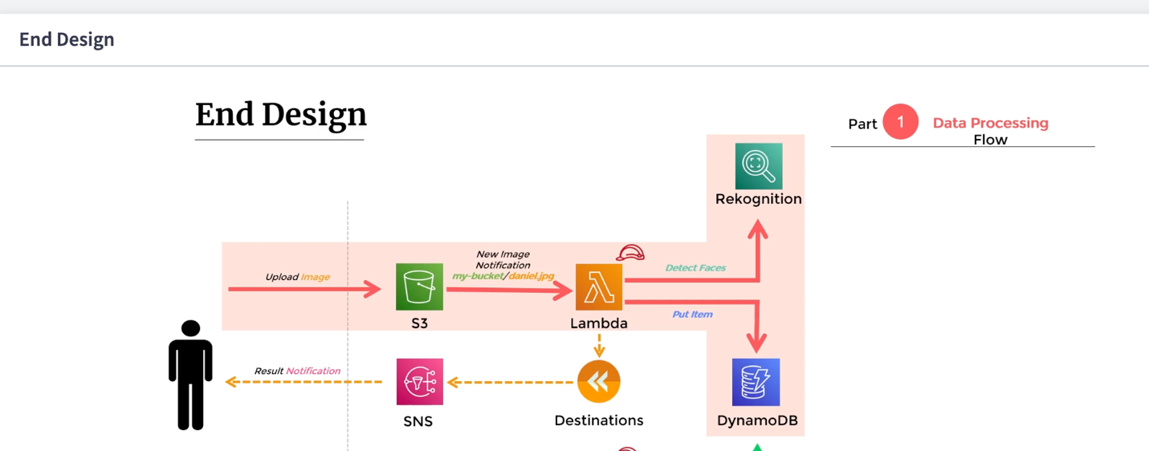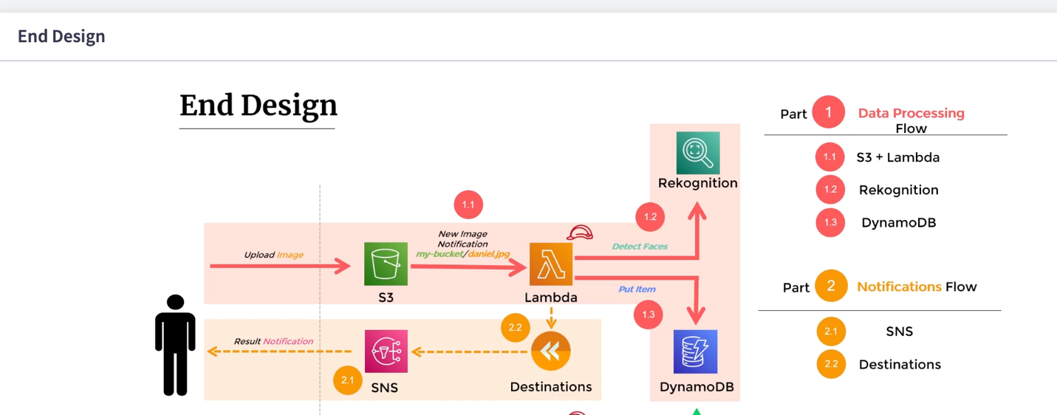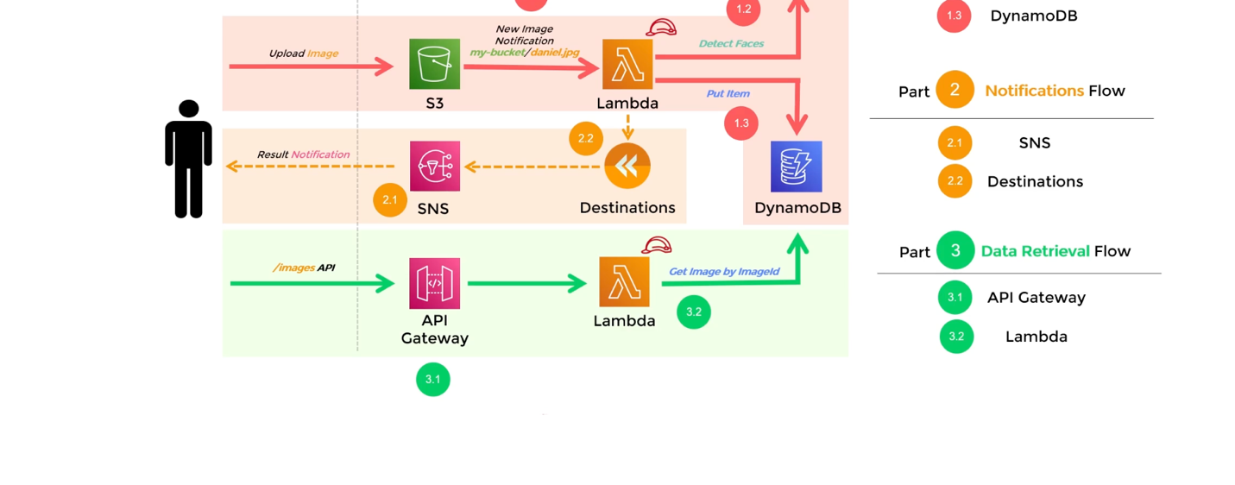

**1.1 S3 + Lambda**



Anytime a new object is loaded to s3 bucket, lambda function will be triggered

**S3 Lambda Function Integration**

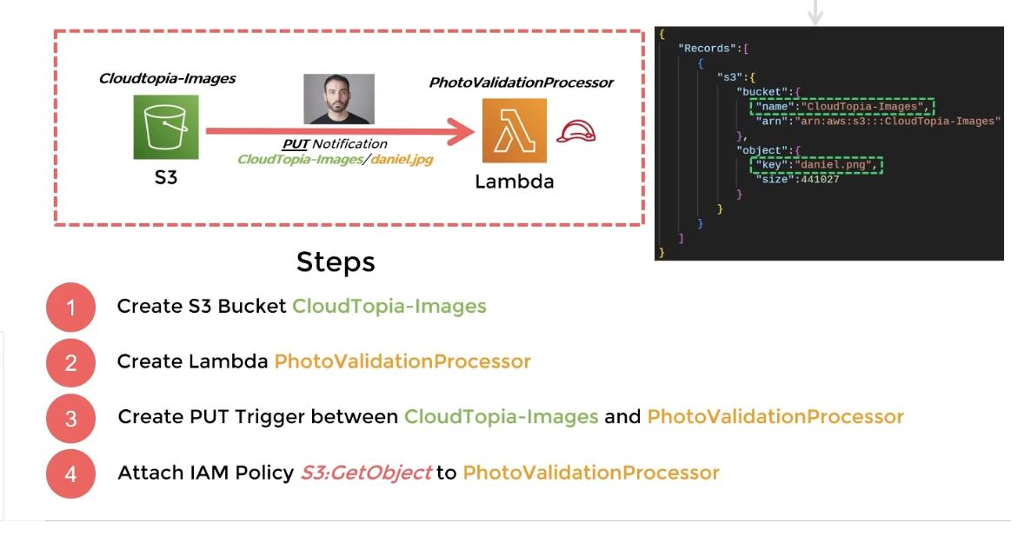

1

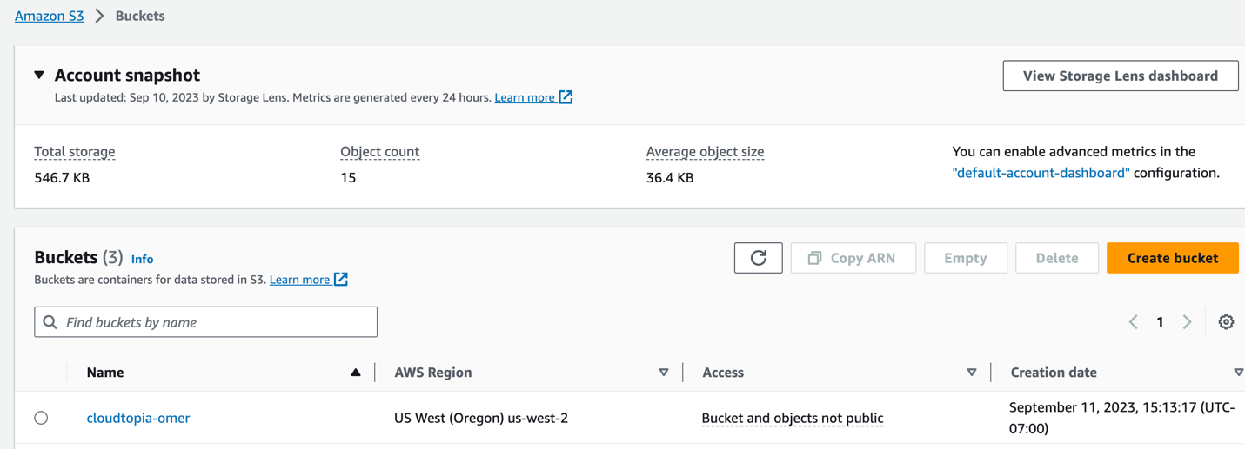

2

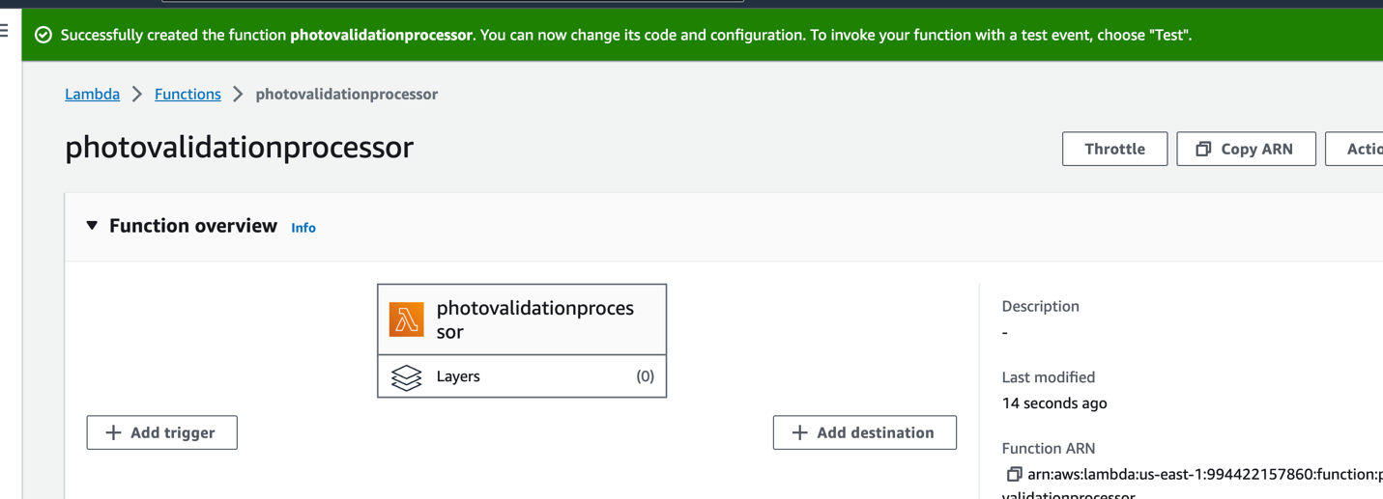

3

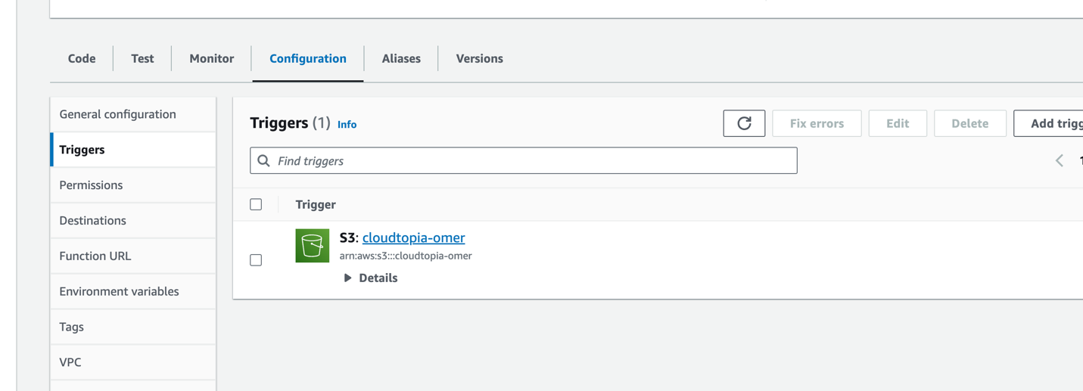

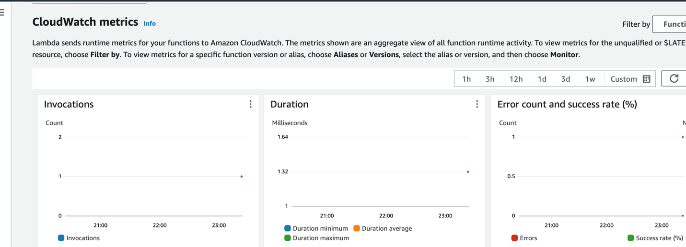

**Integrating with Amazon Rekognition**

**Detect faces API**

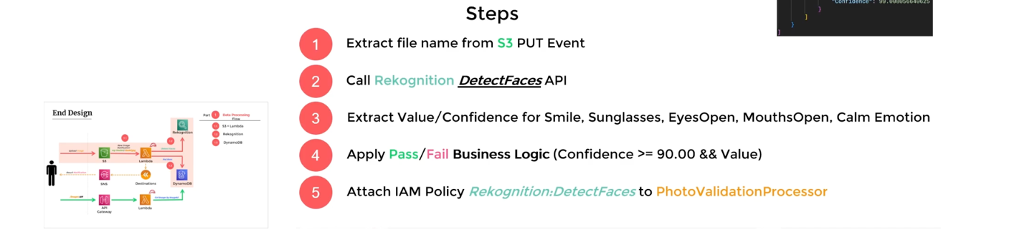

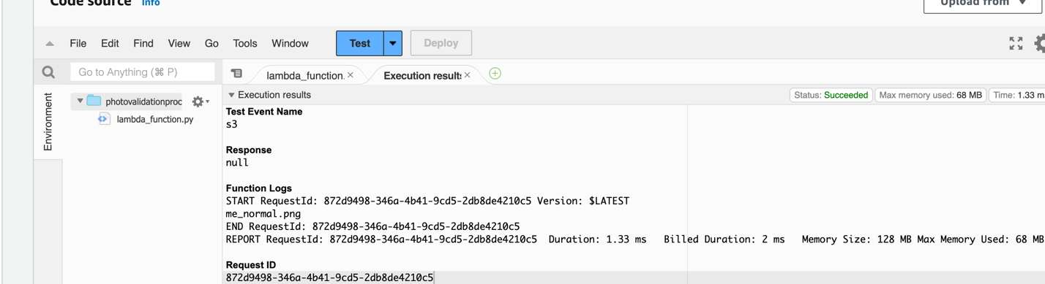



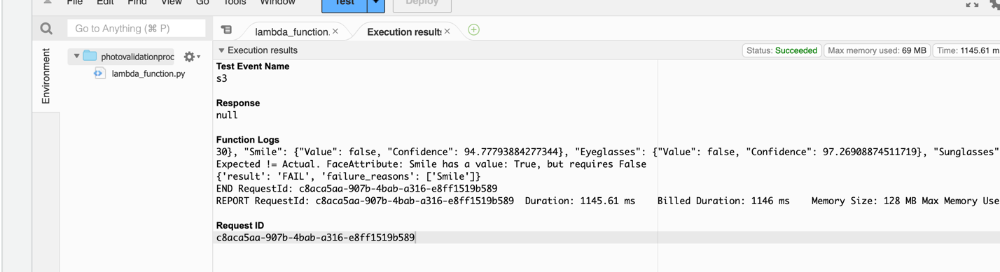

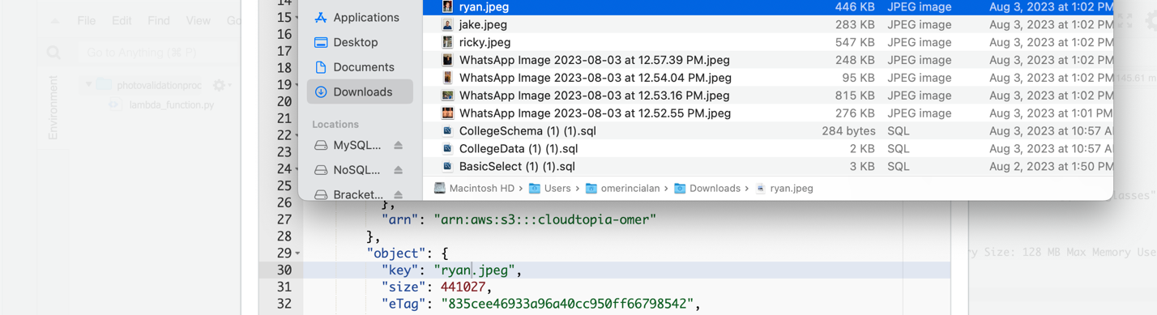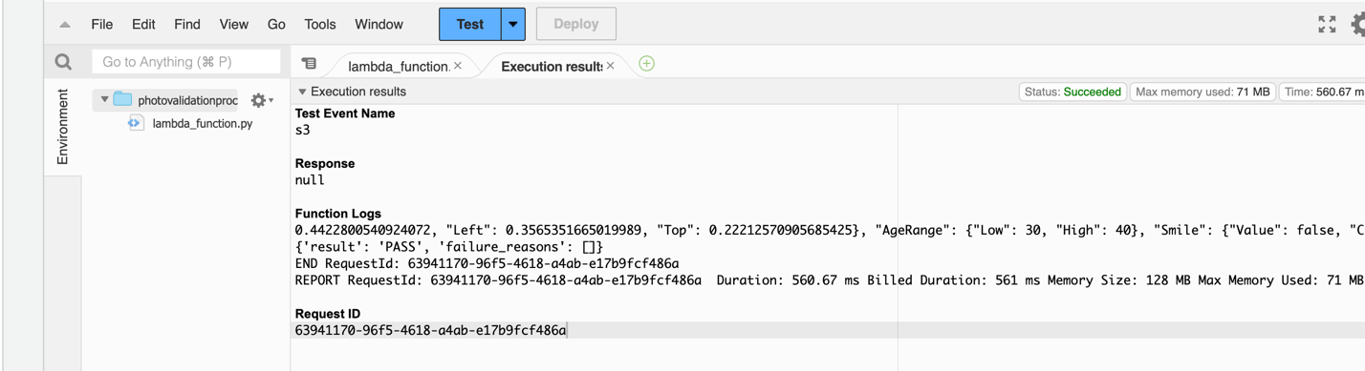

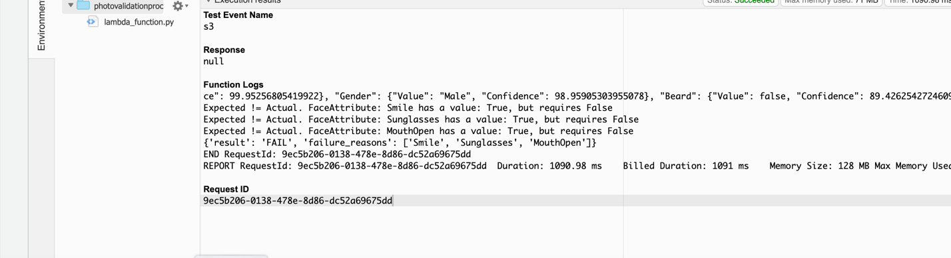

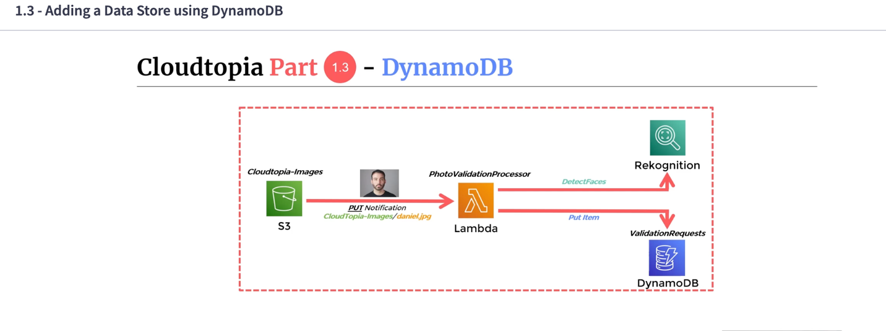

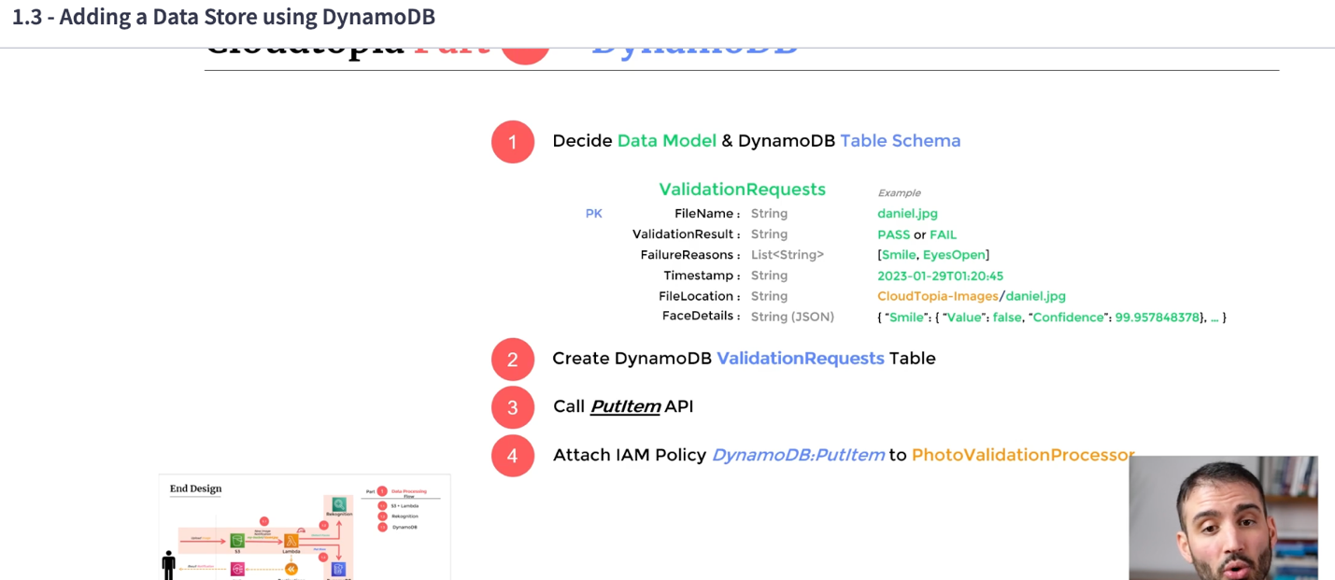

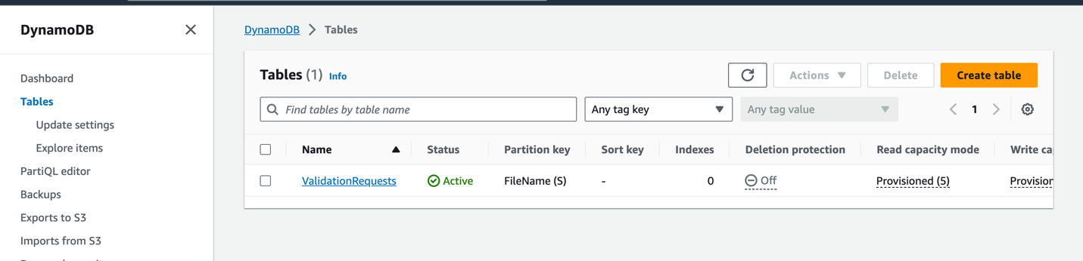

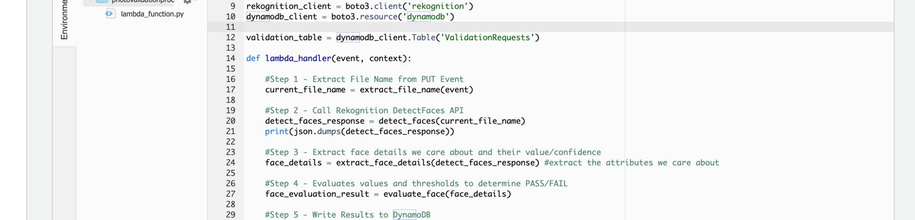

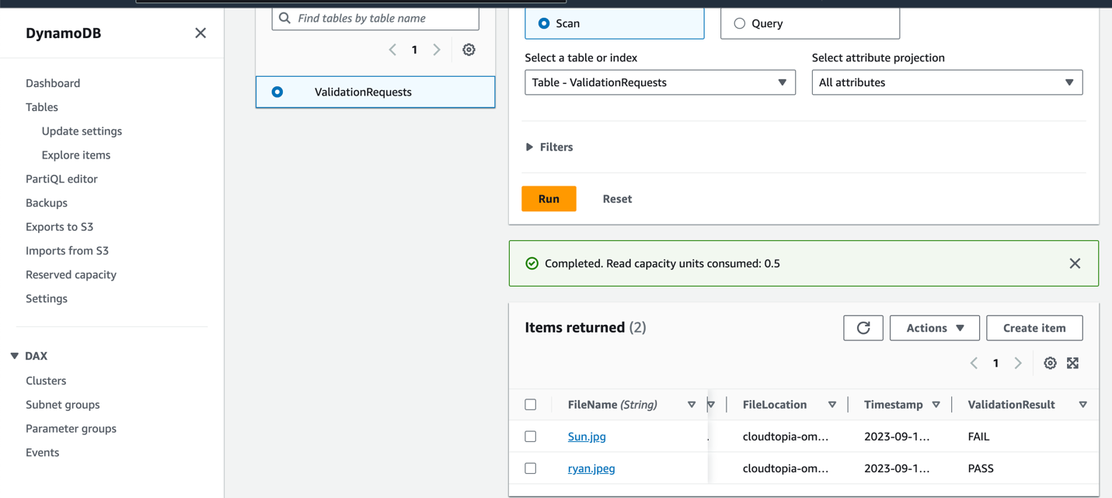

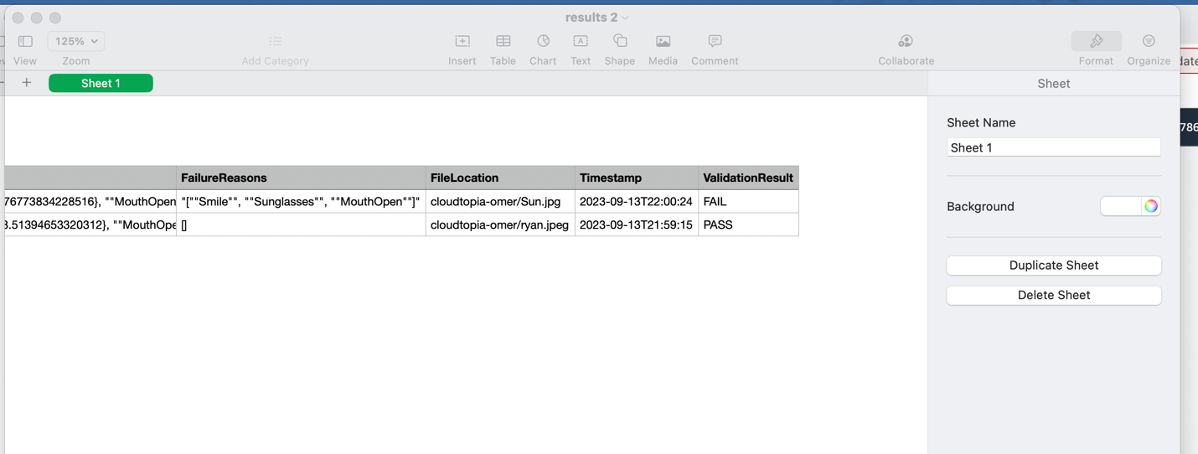

2.0

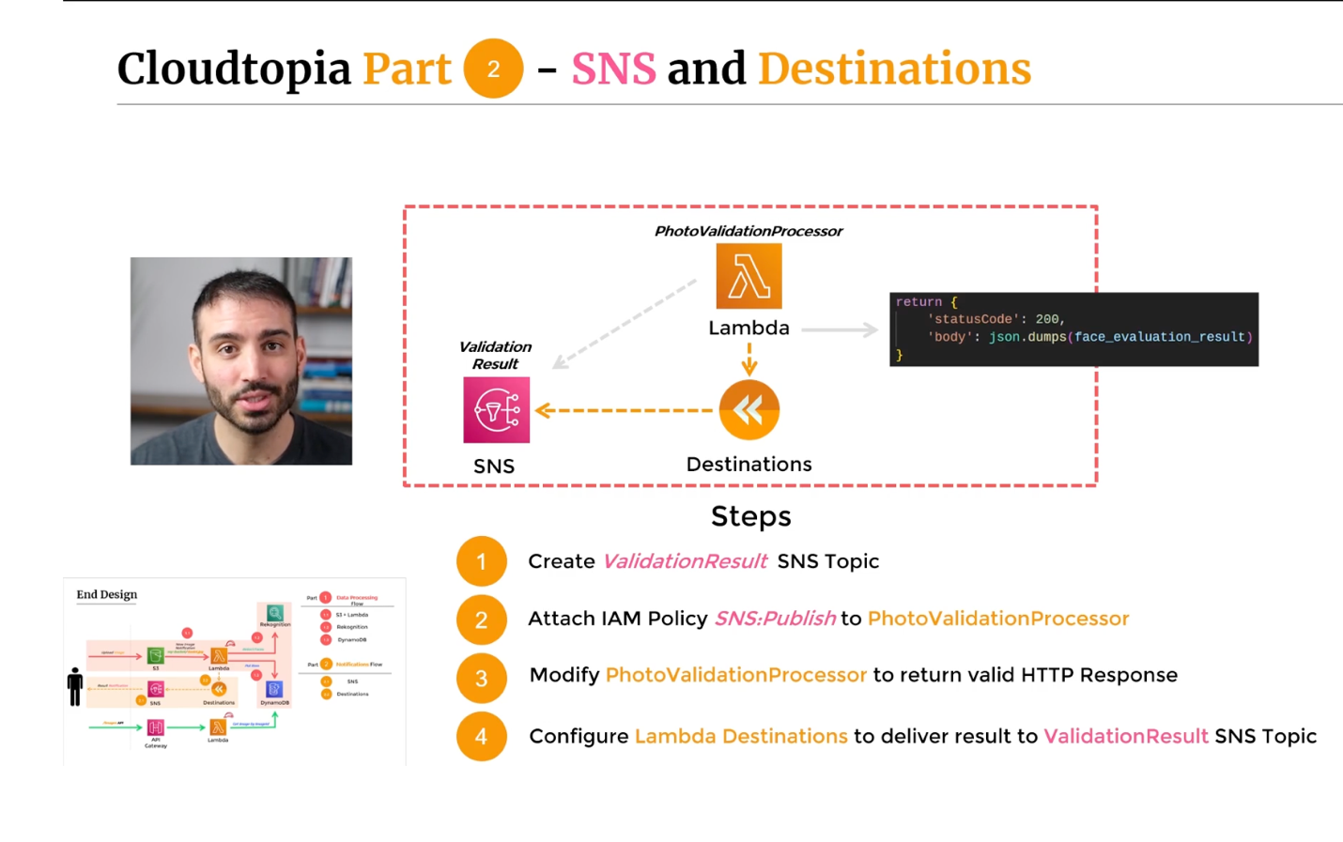

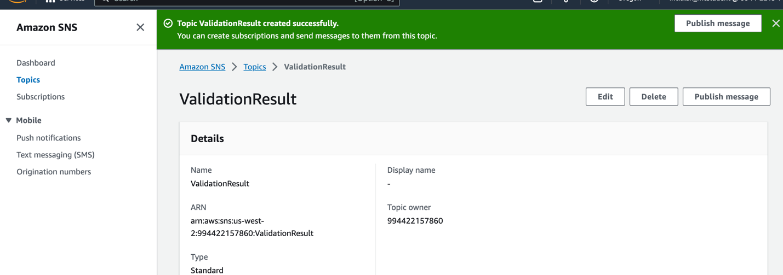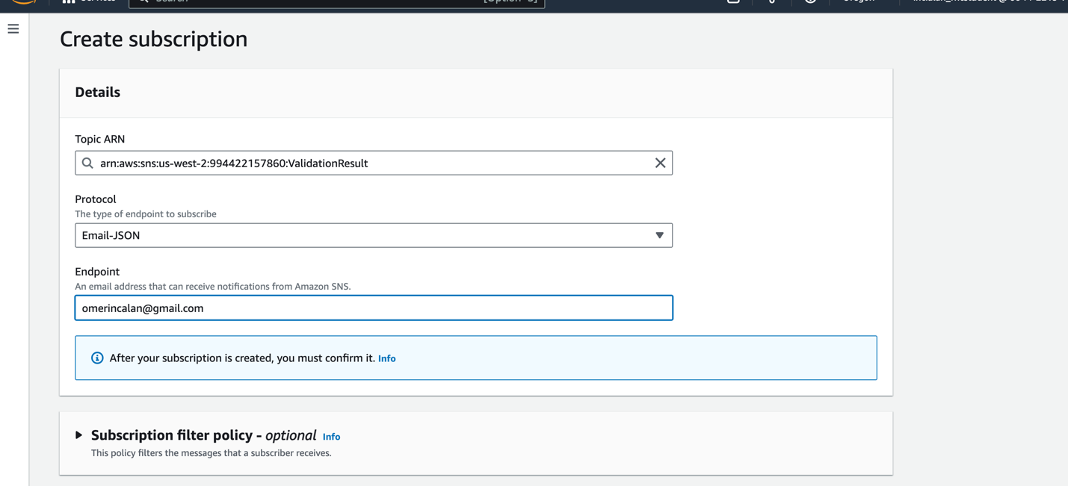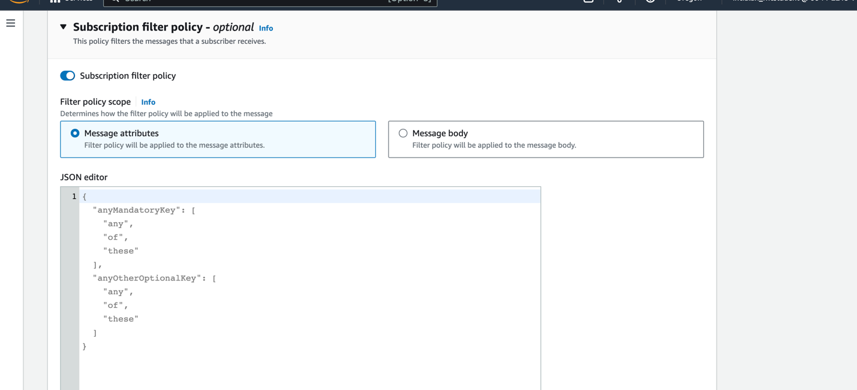

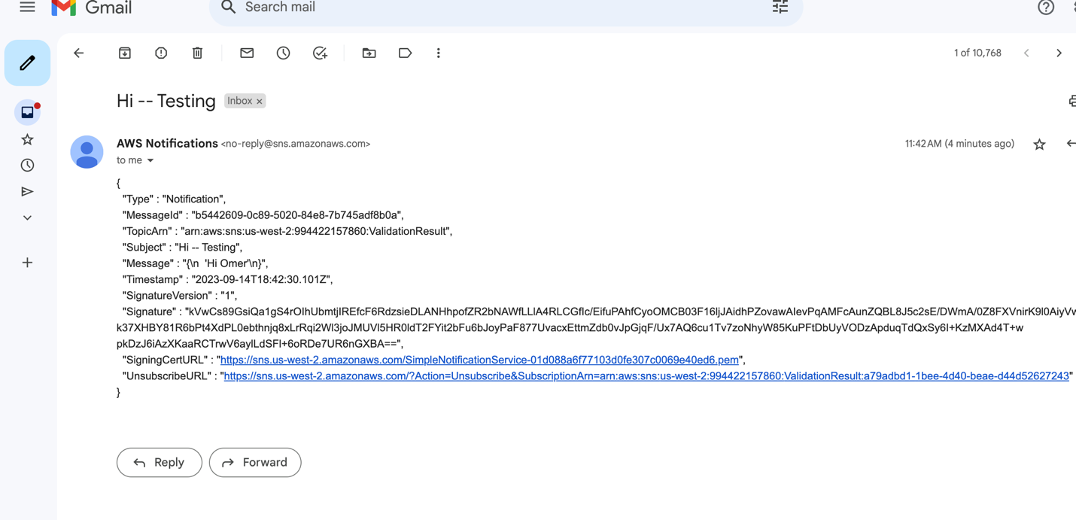

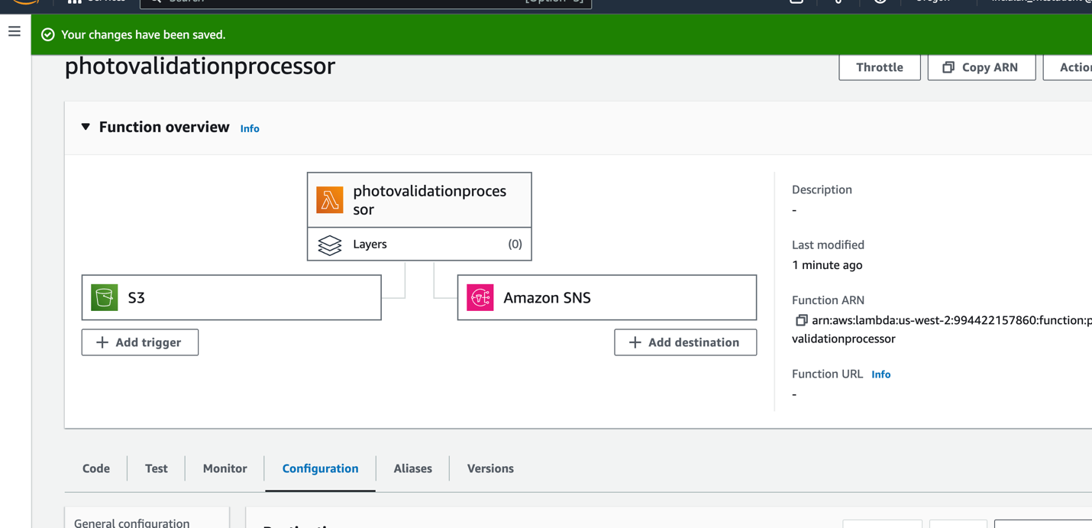

Test does not trigger SNS. You need to add file into S3 Bucket.

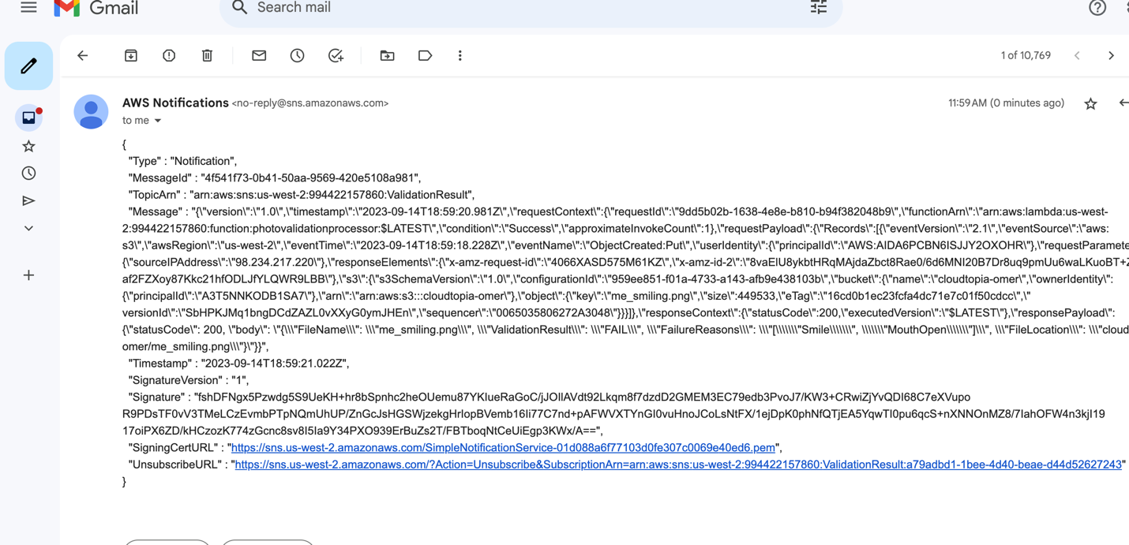

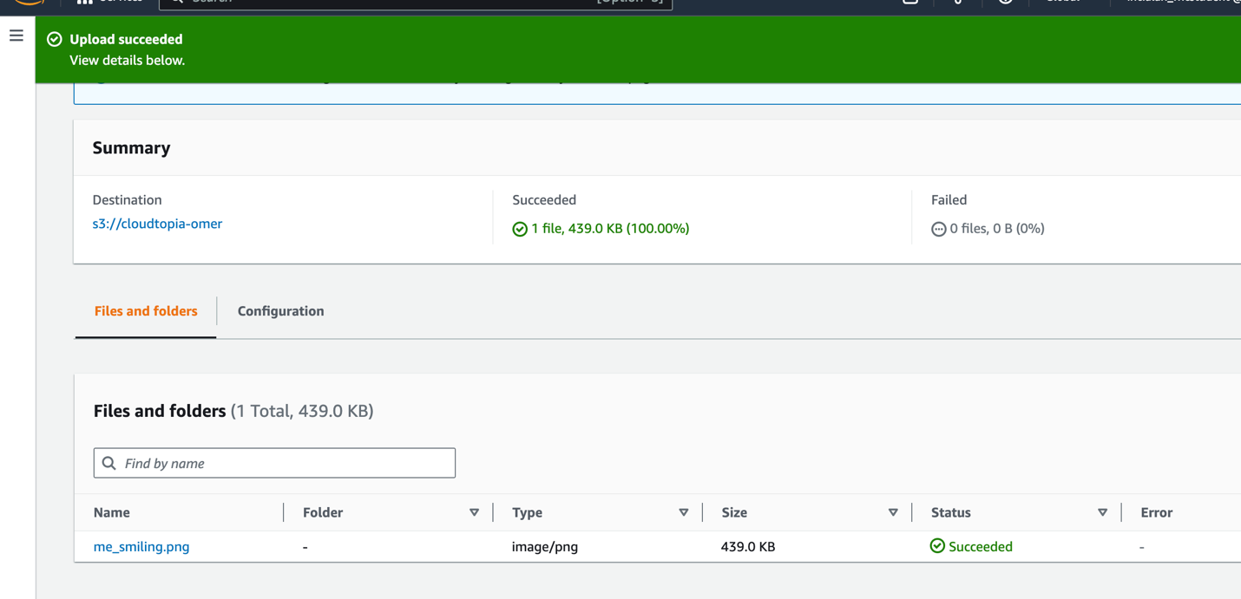

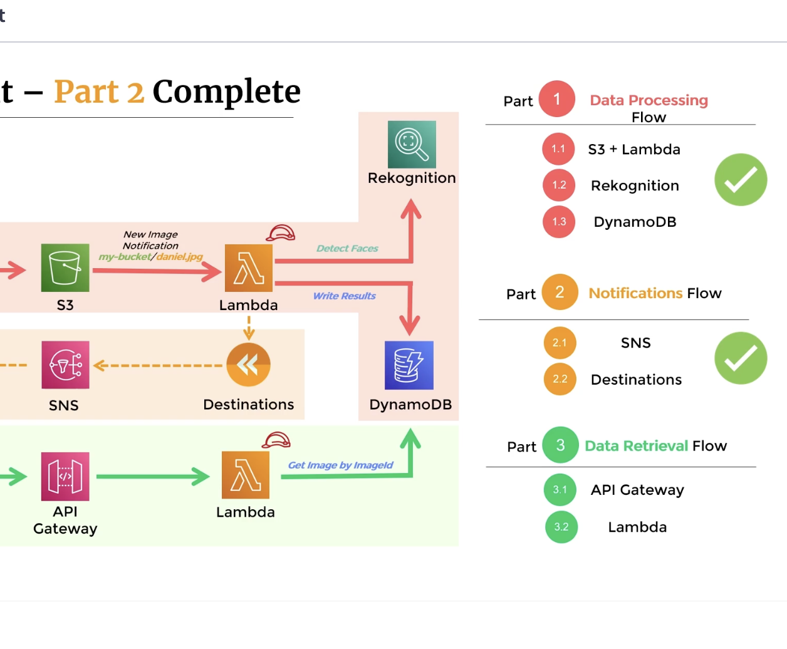

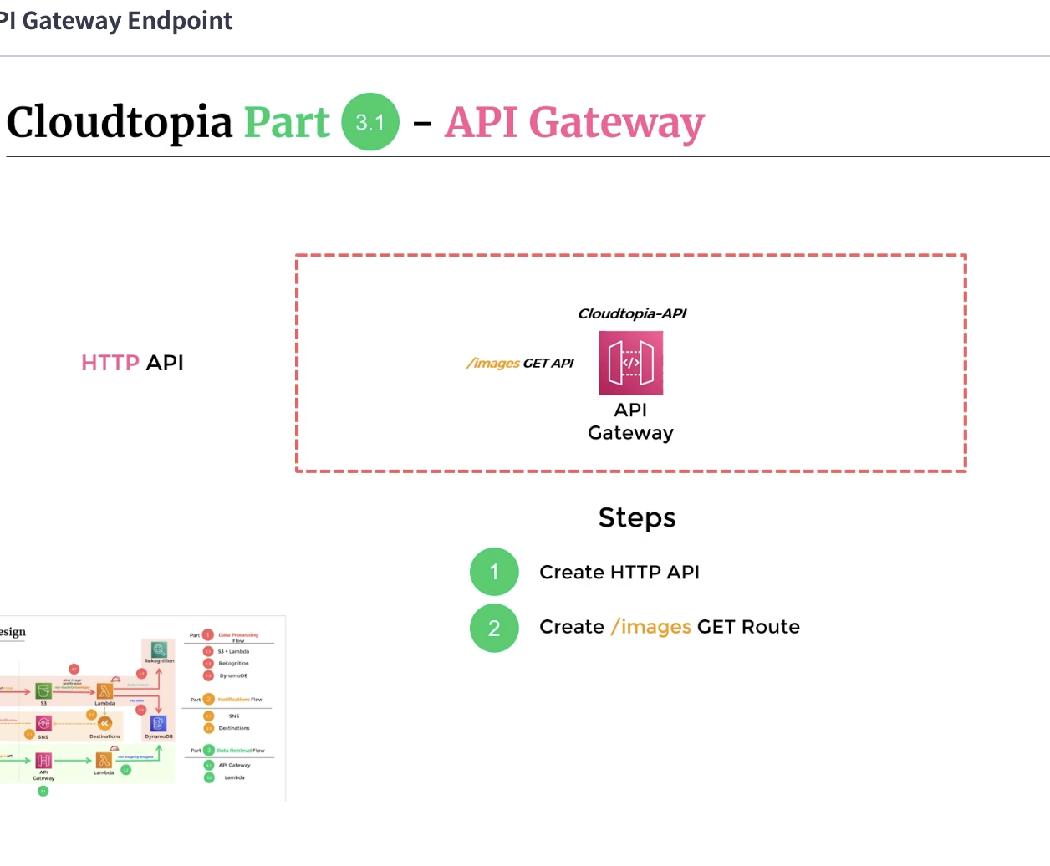

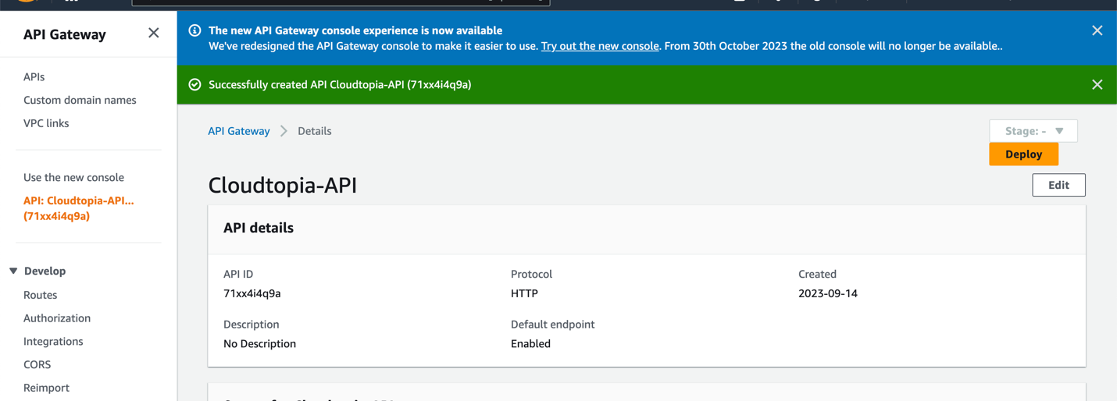

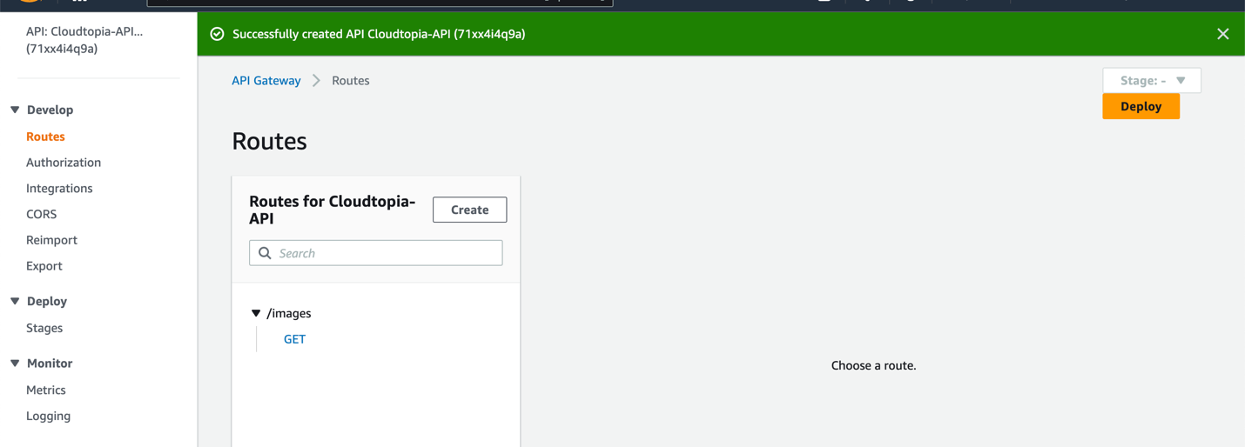

3.0

